JUST REGULAR INFO that Professor shared during the lectures regarding the final project

This is just a suggestion/ prof shared during lectures so it’s not all correct and followed everything , may help it, otherwise can ignore it .

Follow the document that I shared for option 1 and option 2

* The sample project is Missing many features, follow the guidelines that's been given you to yo , if you miss any feature you will lose points
* Project should have read me file , on how to test the project

Sample project :

Sam Palindrome yango function example. It's not a project

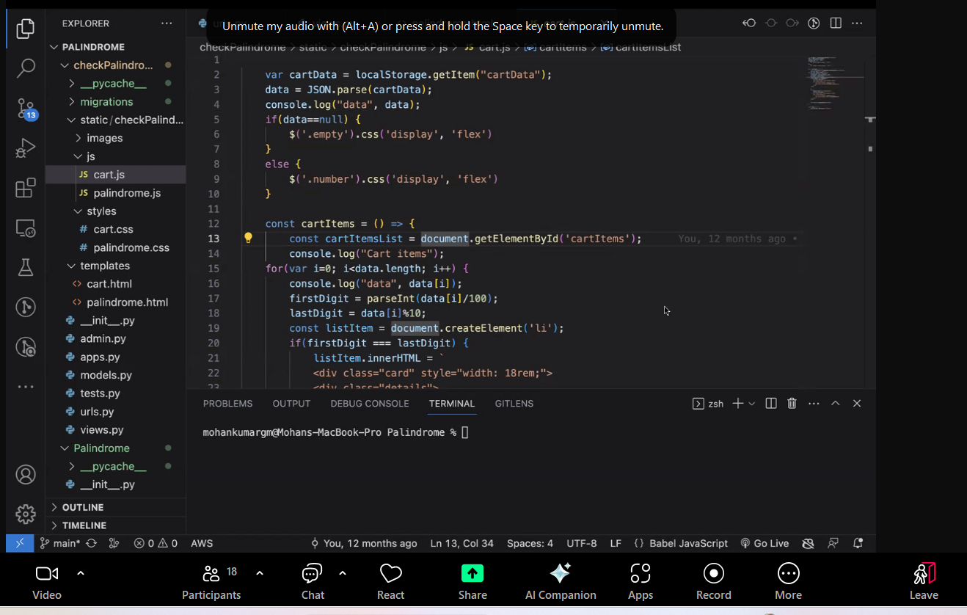

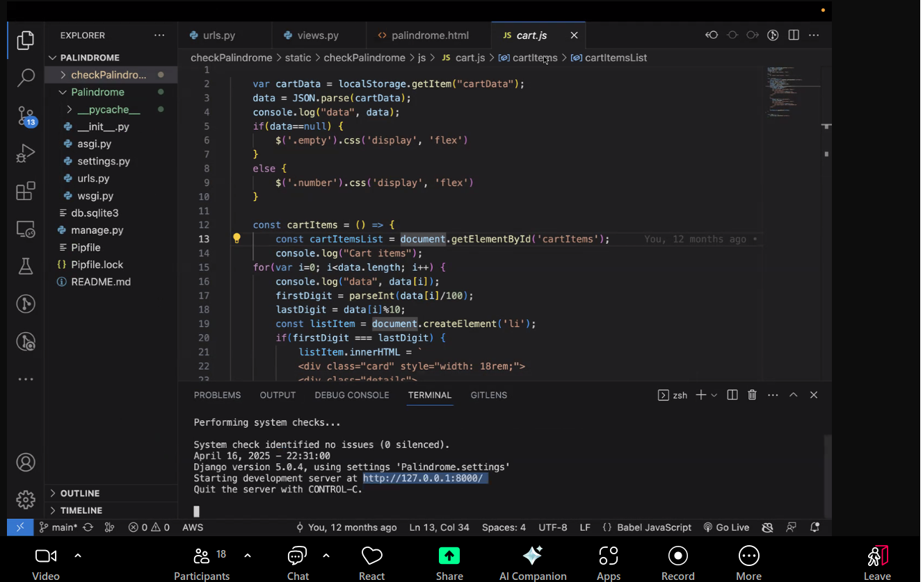

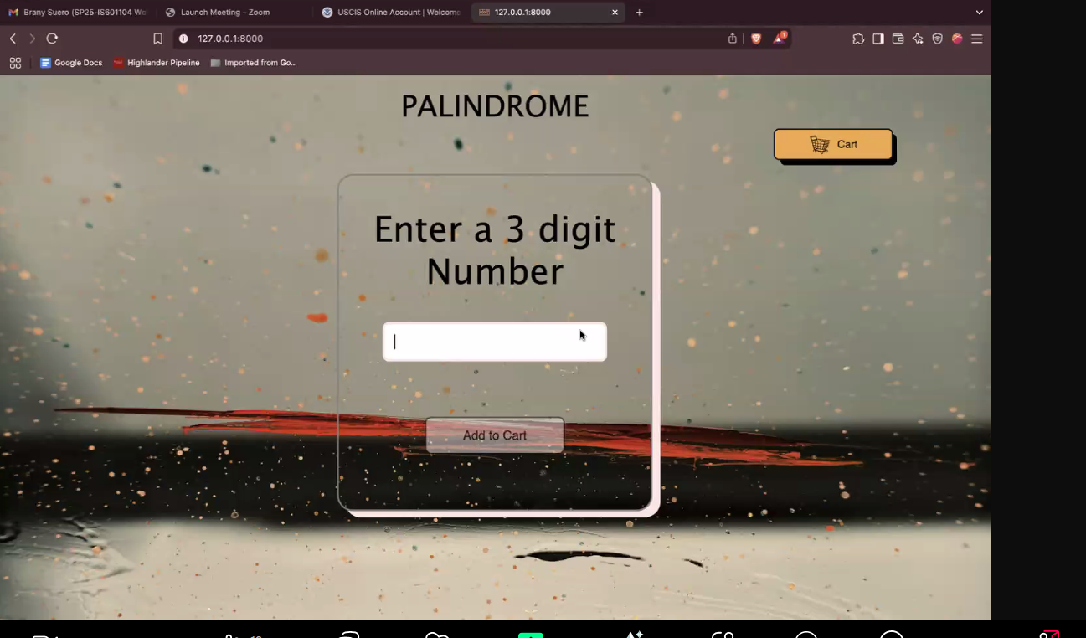

You should be able to add it and remove it, readd it

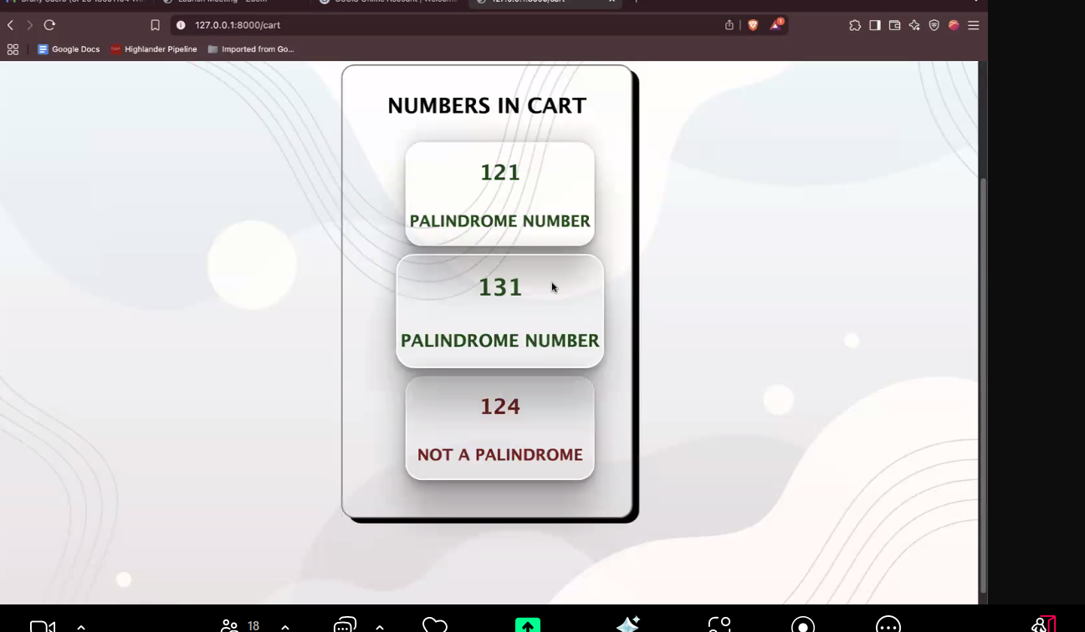

For your

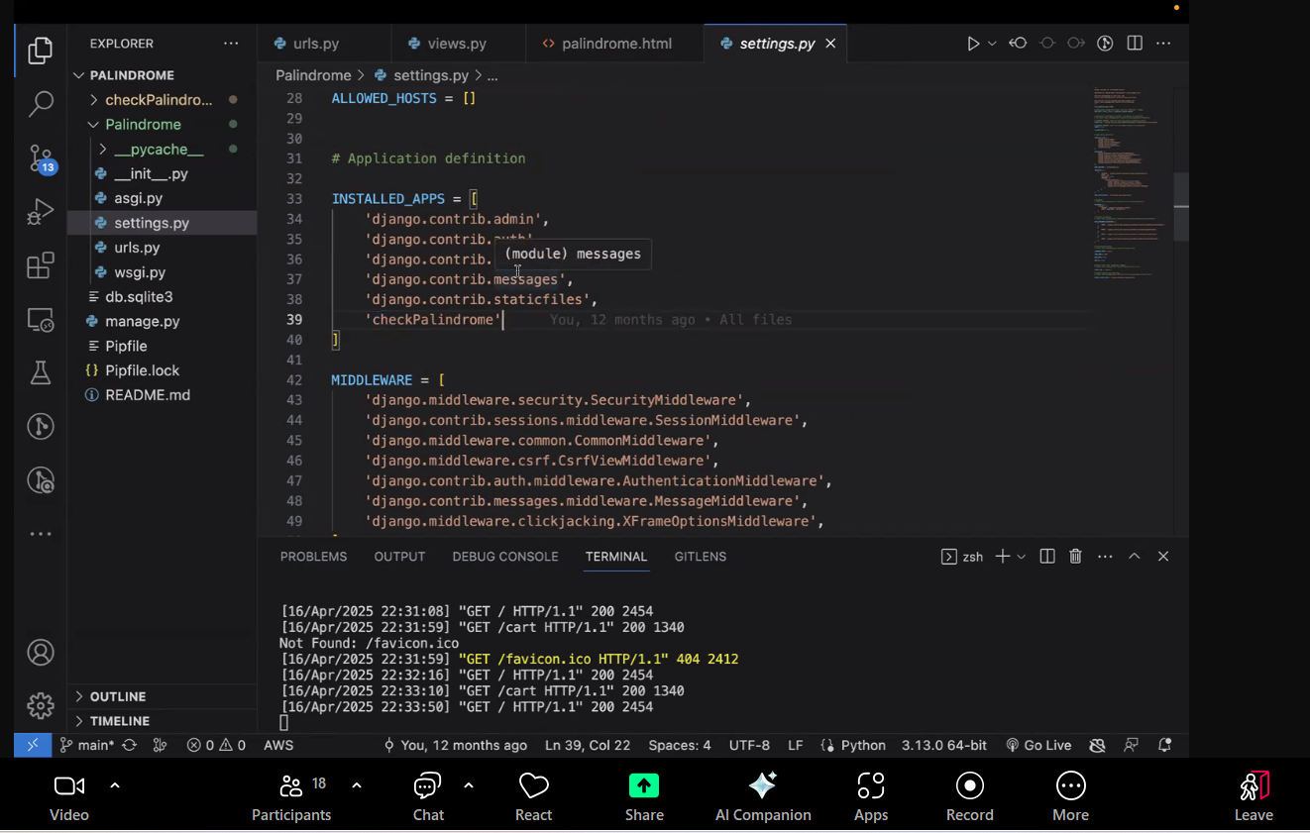

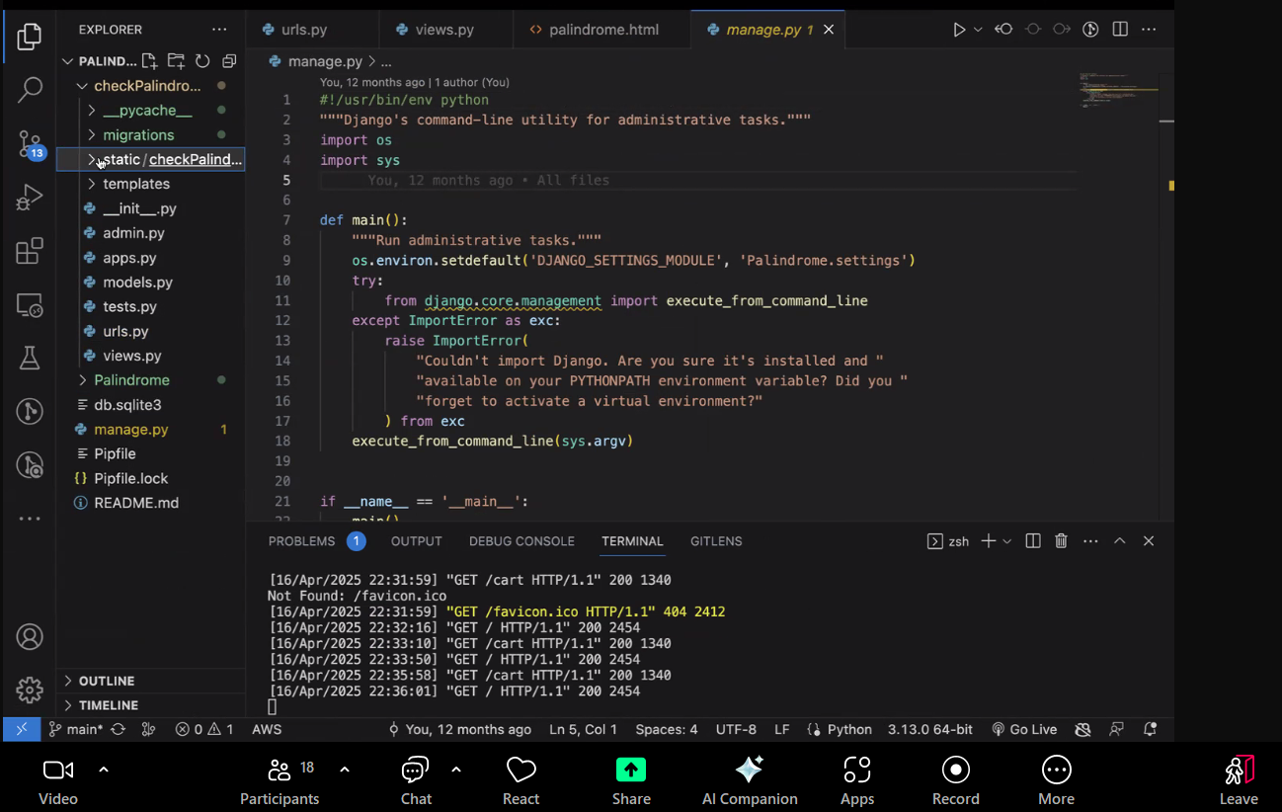

Sample project:

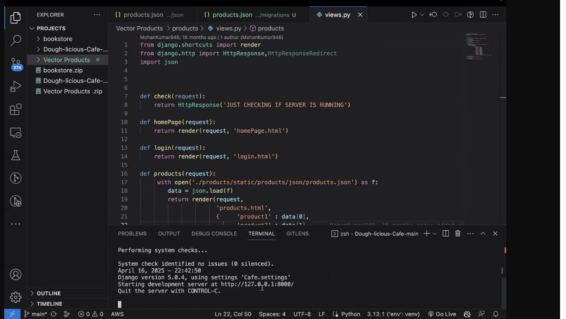

Home screen for the project

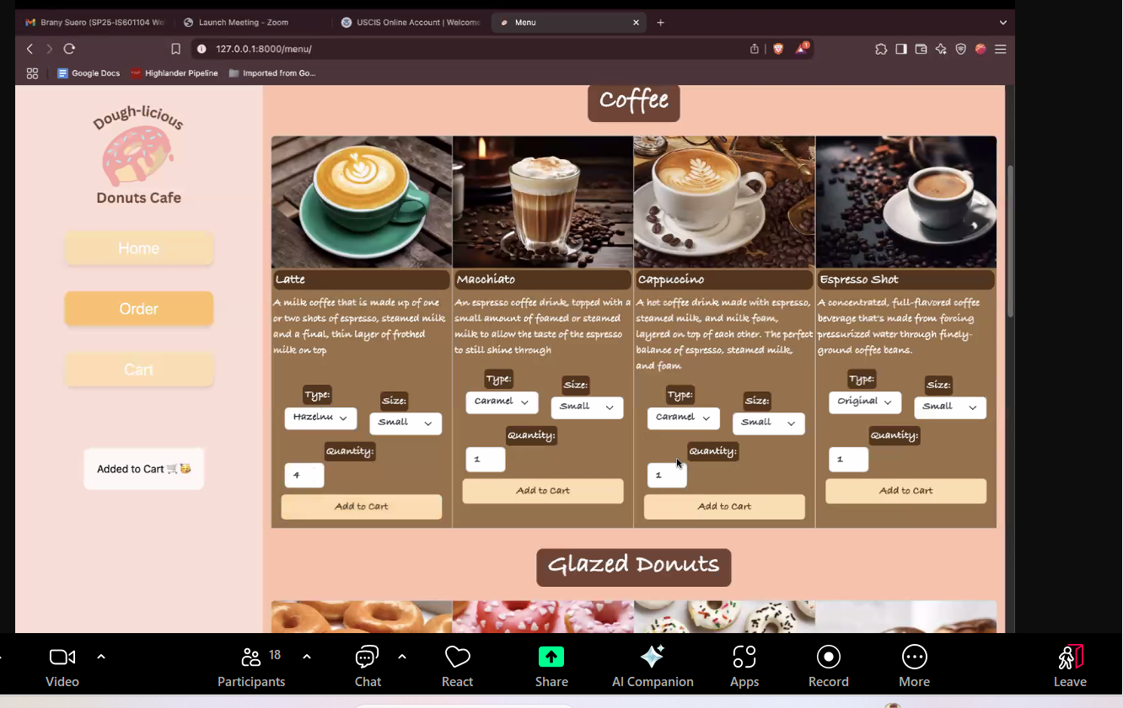

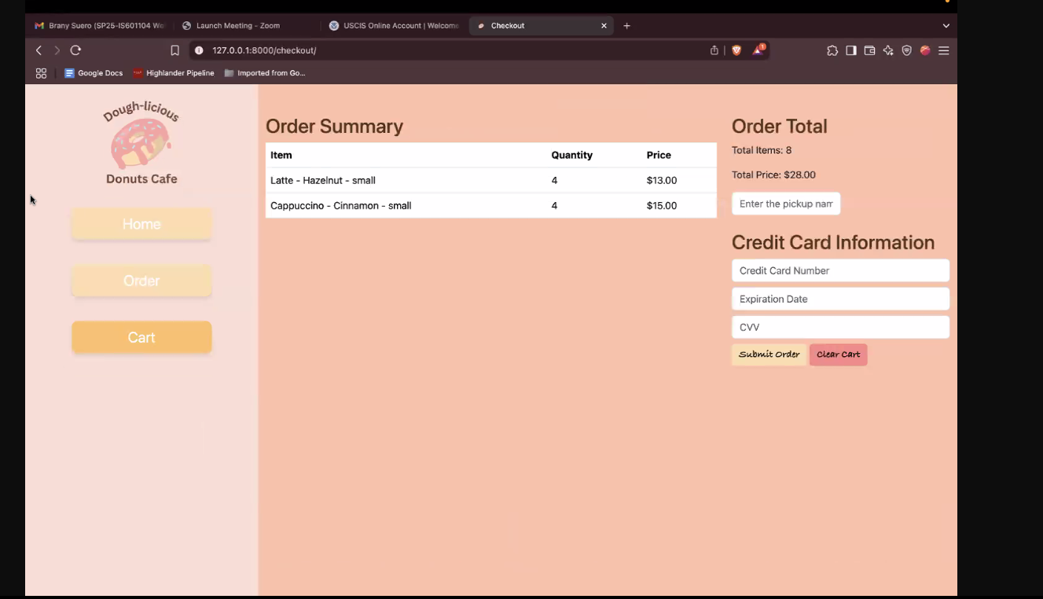

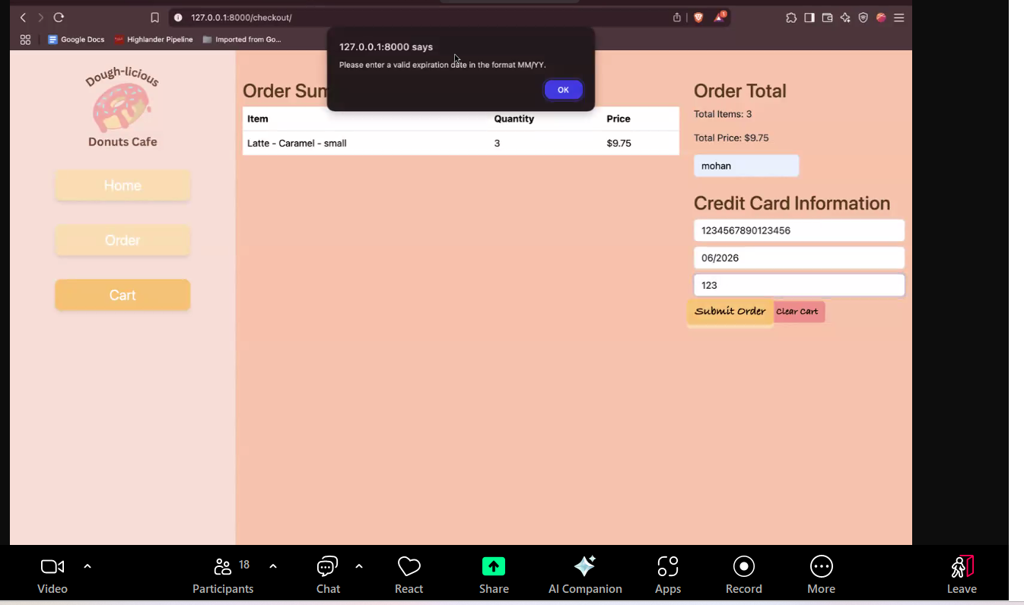

**2nd Project:**



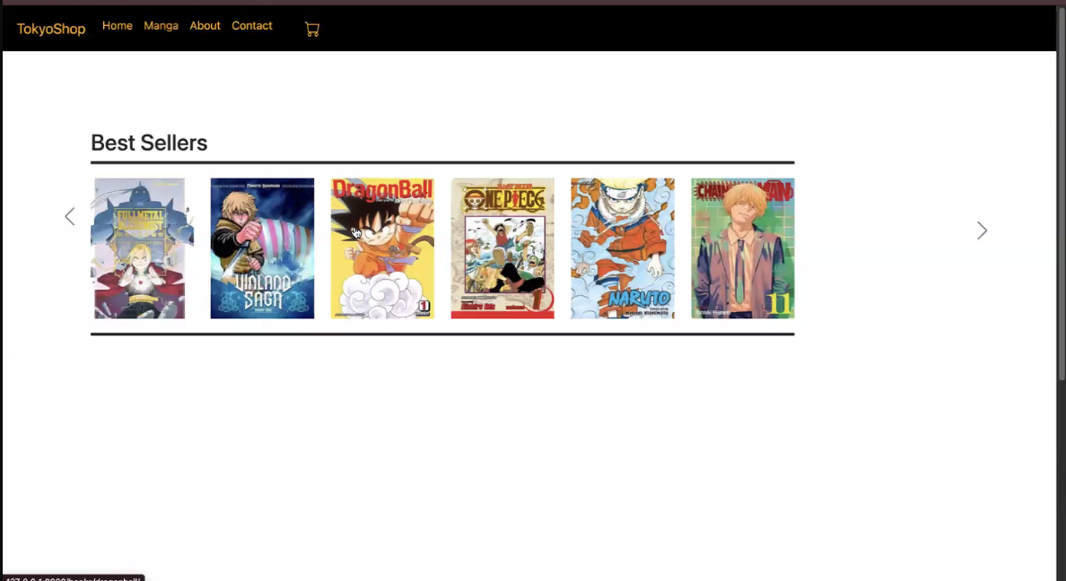

Once the ordre ois complete , make sure sure

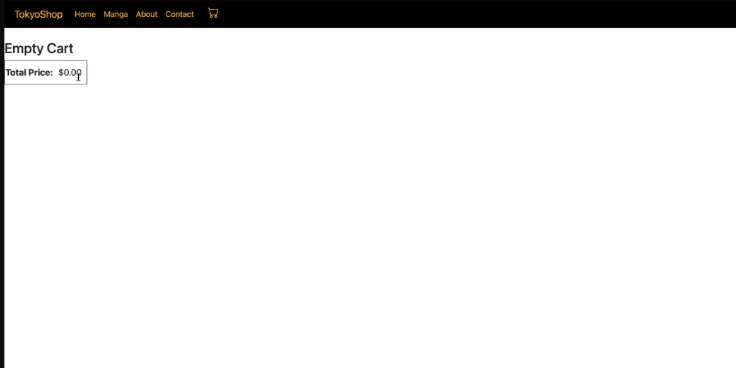

Missing many features, follow the guidelines that's been given you to yo , if you miss any feature you will lose points

Project should have read me file , on how to test the project